New Century Health Clinic

Systems Analysis, Comparison and Recommendation

Comparison

There are two options for New Century Health Clinic at this point. The first option is to create an entirely new system for New Century Health Clinic, from the ground up using an in-house development team. The other option will be to buy a prepackaged Vertical system. These plans will be referred to as “in-house” and “vertical” systems, respectively.

Each plan shows similar Total Cost of Ownership (TCO), with the vertical system showing slightly higher investment of $29,698, but spread out a bit more evenly during a 5 year planning cycle. The net present value of the vertical system will be $70,408.

|  |  |  |  |  |  |  |  |
| --- | --- | --- | --- | --- | --- | --- | --- |
| **DATA FOR PLAN B: Purchase Vertical Software Package** | | |  |  |  |  |  |
|  | **Year 0** | **Year 1** | **Year 2** | **Year 3** | **Year 4** | **Year 5** |  |
| **Costs:** |  |  |  |  |  |  |  |
| Purchase price for vendor package | 3,000 | 3,000 | 3,000 |  |  |  |  |
| Tech support contract |  | 500 | 500 | 500 | 500 | 500 |  |
| Consultant time to install, configure, and test | 4,800 |  |  |  |  |  |  |
| Hardware | 5,000 |  |  |  |  |  |  |
| Consultant training time | 3,900 |  |  |  |  |  |  |
| Office staff maintenance, backup, and update | 1,768 |  |  |  |  |  |  |
| **Total Costs:** | 18,468 | 3,500 | 3,500 | 500 | 500 | 500 | 26,968 |

The in-house plan will have a higher cost of initial investment, and slightly higher overall cost, which translates to a Net Present Value of $68,370.

|  |  |  |  |  |  |  |  |
| --- | --- | --- | --- | --- | --- | --- | --- |
| **DATA FOR PLAN A: In-House Development** | |  |  |  |  |  |  |
|  | **Year 0** | **Year 1** | **Year 2** | **Year 3** | **Year 4** | **Year 5** |  |
| **Costs:** |  |  |  |  |  |  |  |
| Consultant time to develop system | 14,440 |  |  |  |  |  |  |
| Purchase necessary software platform | 2,500 |  |  |  |  |  |  |
| Hardware | 5,000 |  |  |  |  |  |  |
| Consultant training time | 3,900 |  |  |  |  |  |  |
| Office staff maintenance, backup, and update | 1,768 |  |  |  |  |  |  |
| **Total Costs:** | 27,608 | - | - | - | - | - | 27,608 |

Each plan will have the same benefit return, which indicates that the faster this project rolls, the sooner the investment will provide returns.

|  |  |  |  |  |  |  |  |
| --- | --- | --- | --- | --- | --- | --- | --- |
| **Benefits:** | **Year 0** | **Year 1** | **Year 2** | **Year 3** | **Year 4** | **Year 5** |  |
| Eliminate overtime | 1,989 | 1,989 | 1,989 | 1,989 | 1,989 | 1,989 |  |
| Eliminate additional position | 8,840 | 17,680 | 17,680 | 17,680 | 17,680 | 17,680 |  |
| Eliminate daily errors | 2,210 | 2,210 | 2,210 | 2,210 | 2,210 | 2,210 |  |
| **Total Benefits:** | 13,039 | 21,879 | 21,879 | 21,879 | 21,879 | 21,879 | 122,434 |

The return on investment can be computed from the previous figures. Each plan shows a similar payback trend. Due to the higher initial cost, the in-house system would start payback in 15 months while the vertical system would achieve payback in about 10 months, with slightly higher cumulative costs.

**In-house plan**

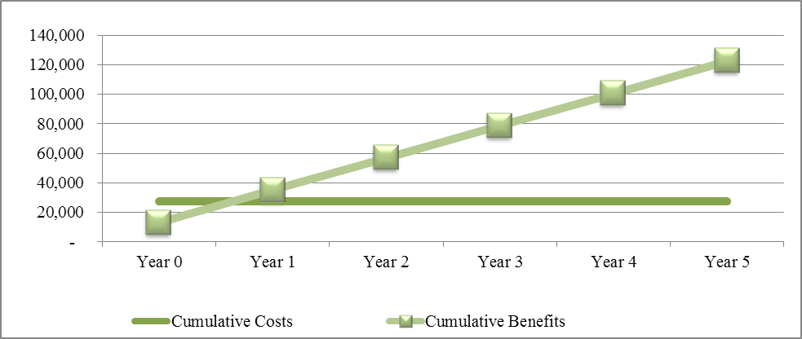

Payback: about 3 months into year 1

**Vertical plan**

The return on investment (ROI) for the in-house system will be slightly less, due entirely to the slightly higher initial cost, with the 5 year ROI being $94,826 or 343% on the in-house plan, and $95,466 or 354% on the vertical plan.

Recommendation

The cost of these two systems is very similar, with the vertical package being slightly cheaper. The real shortfall of the vertical package is that it will not be entirely customizable. This means that if a report is not exactly fulfilling its intended purpose, there may not be the ability to change it, without incurring large fees from the package provider or breaking the service contract. If modifications or service costs to the vertical system are needed at any time that cost more than $640, the ROI would become tipped in the favor of the in-house system.

For this reason, I am recommending using in-house development for this project. The other distinct advantage of using in-house development is that the staff of New Century Health Clinic will be involved in every step of the process, and they will feel as if they have a stake in the success of the system.